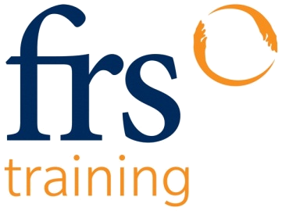

Responding to the training needs of Irish industry
Horticultural Tools and Equipment

Award: Certificate in Horticultural Tools and Equipment (4N0683)
Award Type: Minor QQI Level 4

Duration: 3 days

Programme Content - Learners who successfully complete this Programme will:
- Be able to carry out the pre-start checks of a selection of small engines
- Handle and operate a selection of horticultural tools to a required safety standard
- Be able to select and fit the correct Personal Protective Equipment (PPE) prior to operating horticultural equipment.
- Be able to clean down and complete the post operation check and store away a selection of horticultural tools and equipment
- Be familiar with the relevant Health & Safety legislation and guidelines for handling and operating horticultural tools and equipment.

Entry Requirements: A good command of the English language and a good level of numeracy and literacy.

Max numbers of participants: 12

Facilities: Classroom and Work area

Why should I attend? Learners who are successful on this programme may carry forward a credit towards a major award in the future.

Certification: Successful applicants will receive a QQI level 4 Certificate in Horticultural Tools and Equipment

Assessments: The learner is required to complete - Skills Demonstration 80% and Examination 20%

Learner supports: Learners will be supported by the tutor outside of formal delivery of the programme if required. Participants are not expected to engage in independent learning outside of the formal training.

1890 20 1000 info@frstraining.com www.frstraining.com

